Drone vs. Bird Detection System - Design Document
BY: S Kausik Ragav

Problem Statement
The objective was to design an automated defense system capable of distinguishing between drones and other aerial objects (birds) using a Deep Learning approach. The main challenge is differentiating between two small, flying objects that often share similar bodies or figures against complex sky backgrounds.

Data Pipeline Design
To ensure efficient training on the provided dataset, I implemented the following preprocessing steps:

Resolution: I chose an image size of (100, 100). This is a trade-off; it is large enough to capture the rotor details of a drone but small enough to allow for a larger batch size (32) on limited hardware (8GB RAM laptop).
Normalization: Pixel values were rescaled from [0, 255] to [0, 1] using a `Rescaling` layer. This helps the gradient descent converge faster.
Performance: I used AUTOTUNE with .cache() and .prefetch(). This ensures the GPU/CPU is never waiting for data to be loaded from the disk, effectively parallelizing data loading and model training.

Model Architecture (CNN)
I designed a Convolutional Neural Network (CNN) with three main feature extraction blocks. I chose to make my own CNN over a massive pre-trained model (like ResNet) to keep the model lightweight for potential deployment (e.g., running on the drone/camera hardware itself).

Conv2D Layers I used increasing filter sizes (32, 64, 128) to capture low-level features (edges) first and high-level features (shapes/structures) later.
Batch Normalization: Added after every convolution. This was crucial for stabilizing the learning process and preventing the "vanishing gradient" problem.
Dropout (0.4): A relatively aggressive dropout rate of 40% was placed before the final classification layer. Since the dataset might have similar-looking images, this forces the model to learn robust features rather than memorizing specific pixel patterns (overfitting).
Output:A single neuron with a `sigmoid` activation, ideal for binary classification (0 = Bird, 1 = Drone).

Experiment Tracking (Weights & Biases)
I integrated `wandb` to track the training loss and validation accuracy in real-time. This allowed me to monitor for overfitting (where training loss goes down, but validation loss goes up).

Ablation Study
To understand the impact of specific architectural choices, I conducted a brief ablation study comparing the full model against a simplified version.

Experiment A (Baseline):Full model with Batch Normalization.
Experiment B (Ablation):Removed `BatchNormalization` layers.
Observation:The model without Batch Normalization learned significantly slower and had higher variance in validation accuracy during the first 3 epochs. This confirmed that Batch Norm is essential for this specific dataset configuration. During the ablation study, I reduced the training duration to 3 epochs for speed. I observed that the model failed to generalize, misclassifying a clear image of a drone as a bird with 99% confidence. This confirms that 3 epochs is insufficient for feature convergence, and a longer training schedule (15+ epochs) is required for deployment.
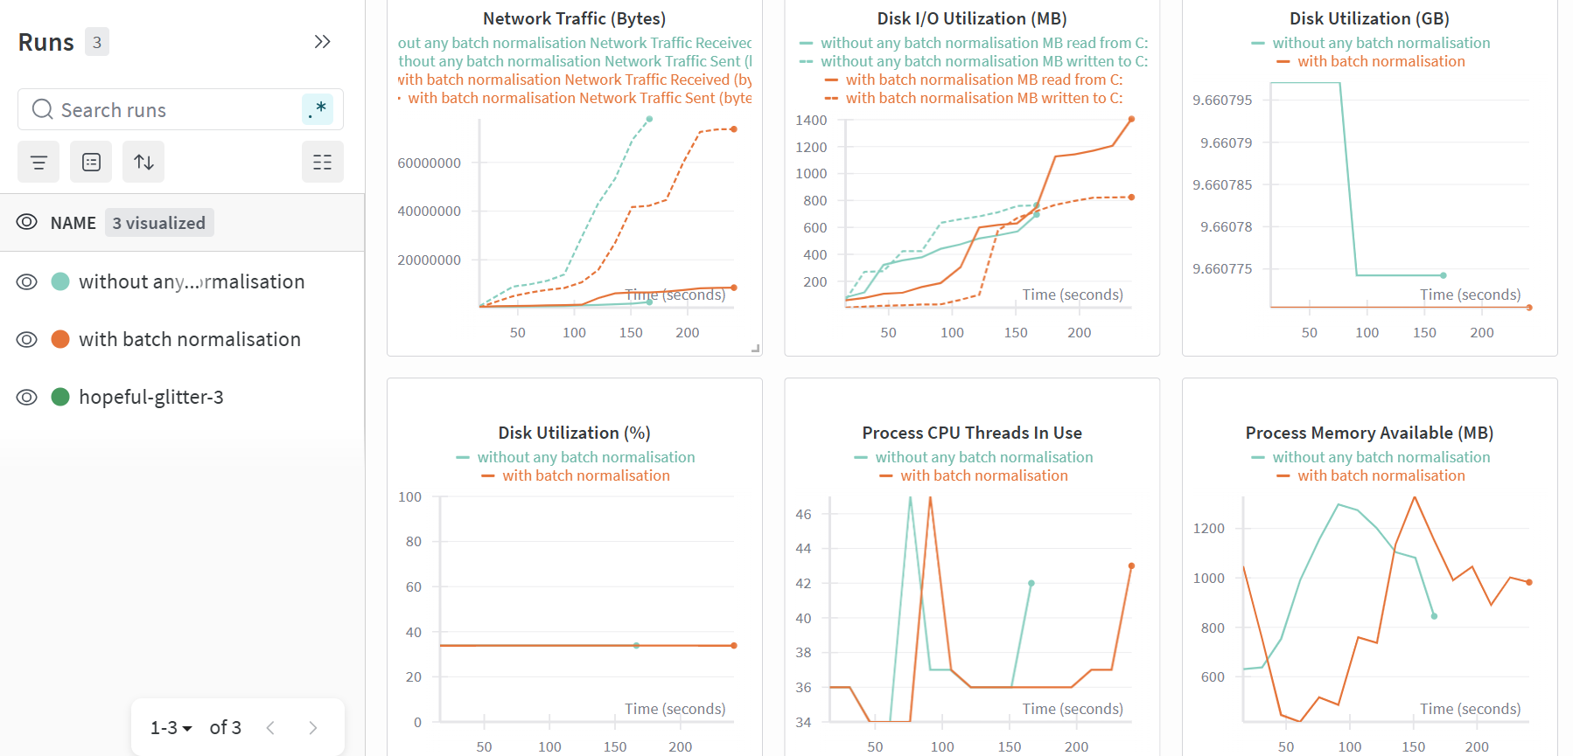

Conclusion
The final model achieves a balance between inference speed and accuracy. The use of a custom lightweight CNN makes it suitable for real-time defense applications where low latency is critical.

